**EXPLORTARY DATA ANALYSIS WITH SQL**

**Task 1**

##### *Display the names of the unique launch sites in the space mission*

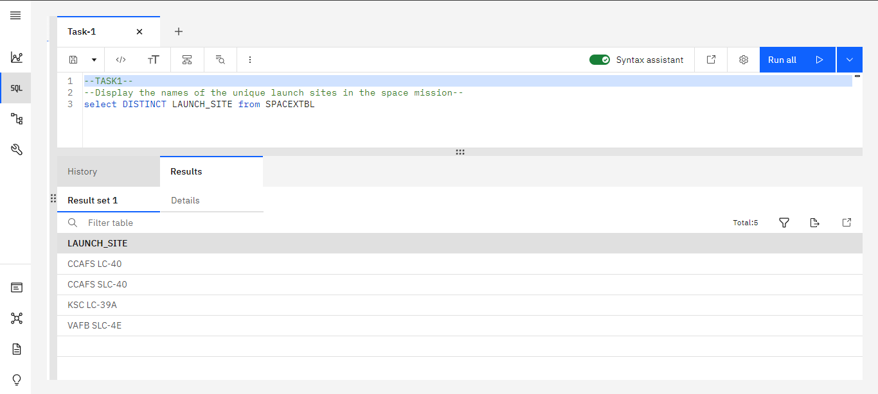

**Task 2**

##### *Display 5 records where launch sites begin with the string 'CCA'*

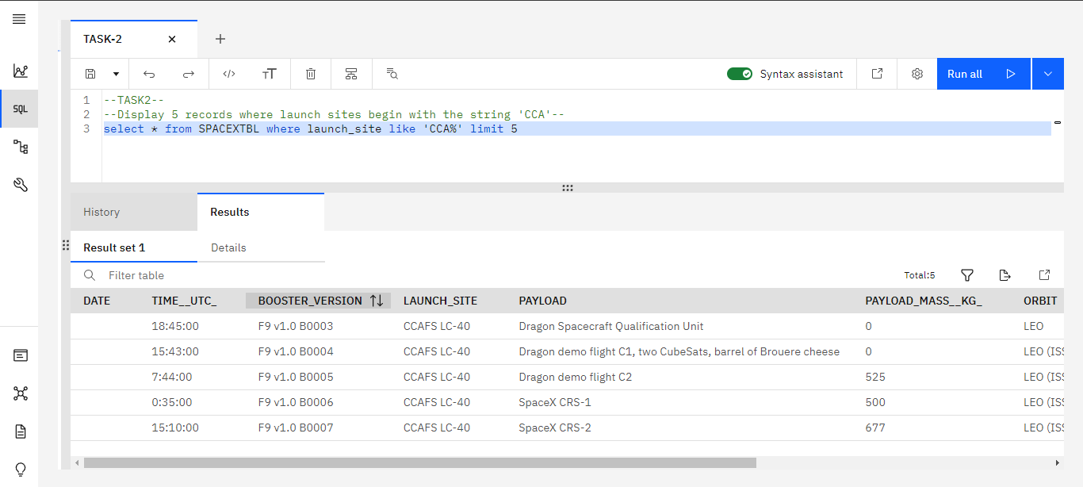

**Task 3**

##### *Display the total payload mass carried by boosters launched by NASA (CRS)*

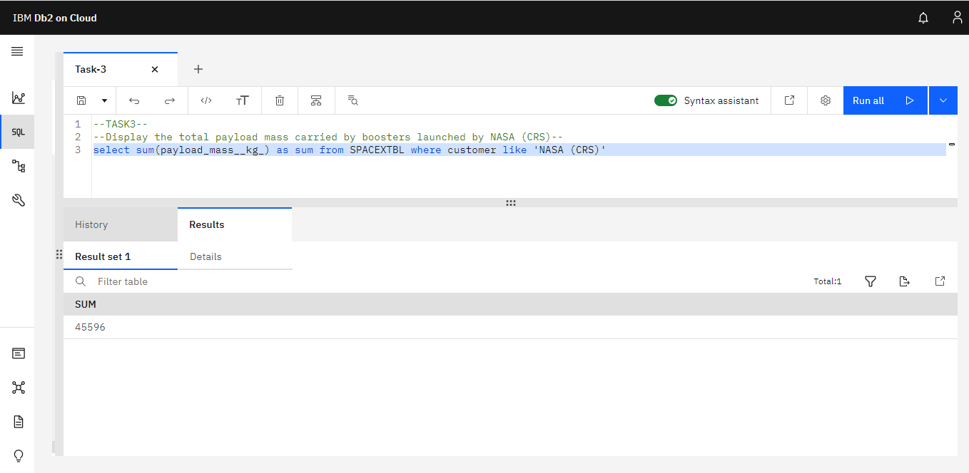

**Task 4**

##### *Display average payload mass carried by booster version F9 v1.1*

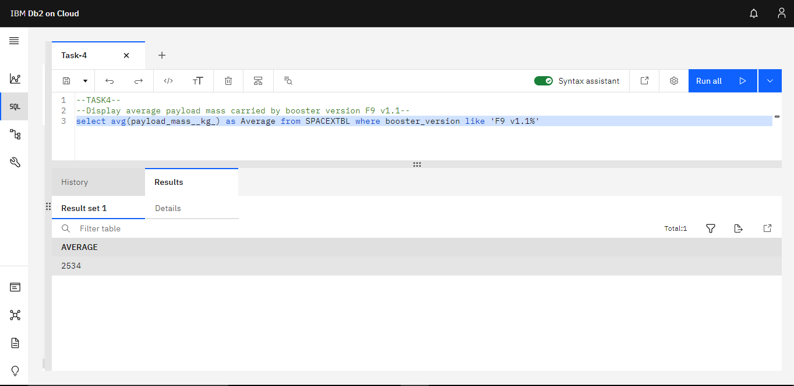

**Task 5**

##### *List the date when the first successful landing outcome in ground pad was achieved.*

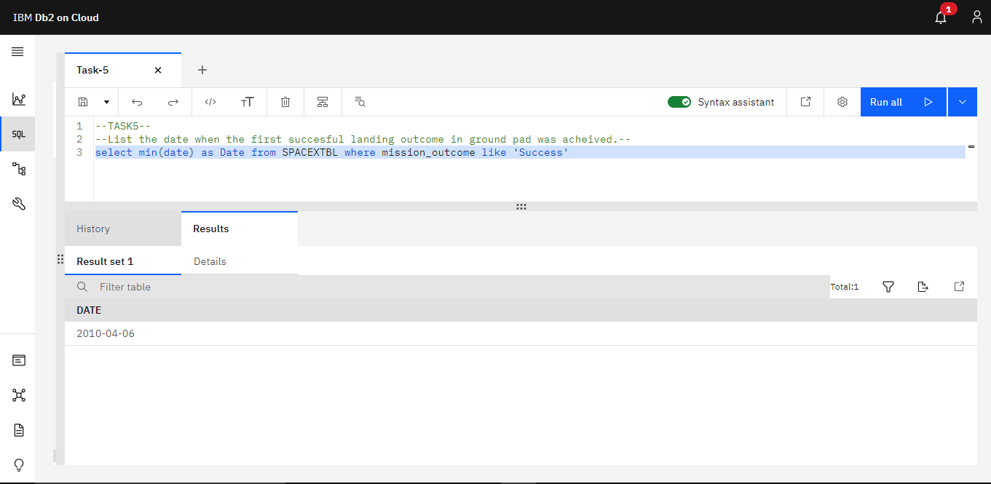

**Task 6**

##### *List the names of the boosters which have success in drone ship and have payload mass greater than 4000 but less than 6000.*

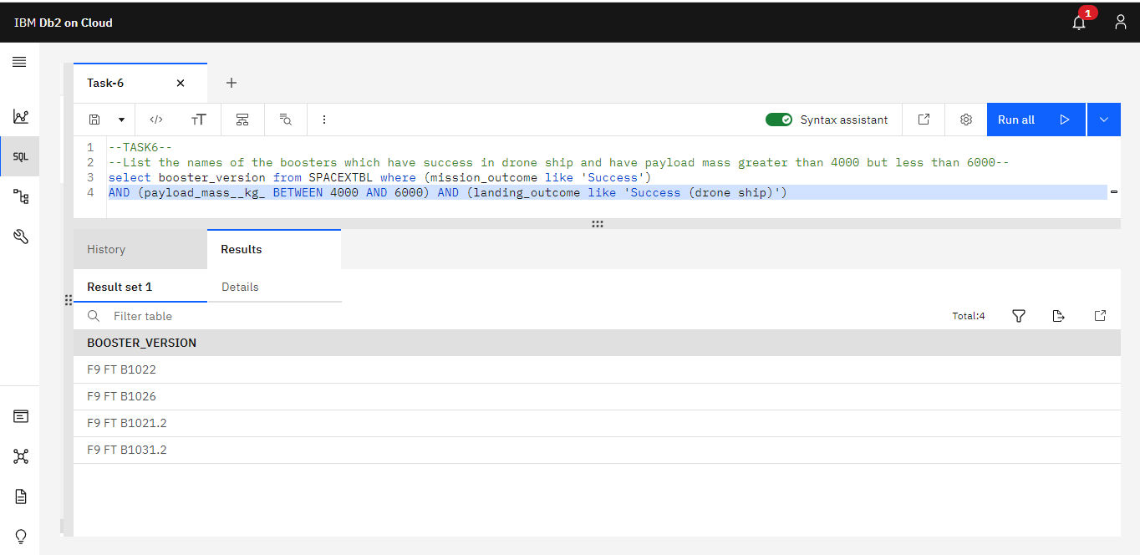

**Task 7**

##### *List the total number of successful and failure mission outcomes*

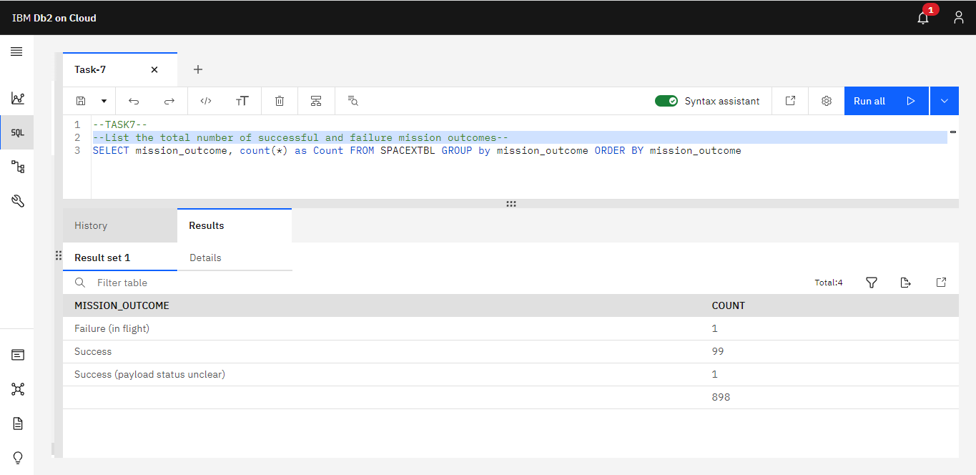

**Task 8**

##### *List the names of the booster_versions which have carried the maximum payload mass. Use a subquery*

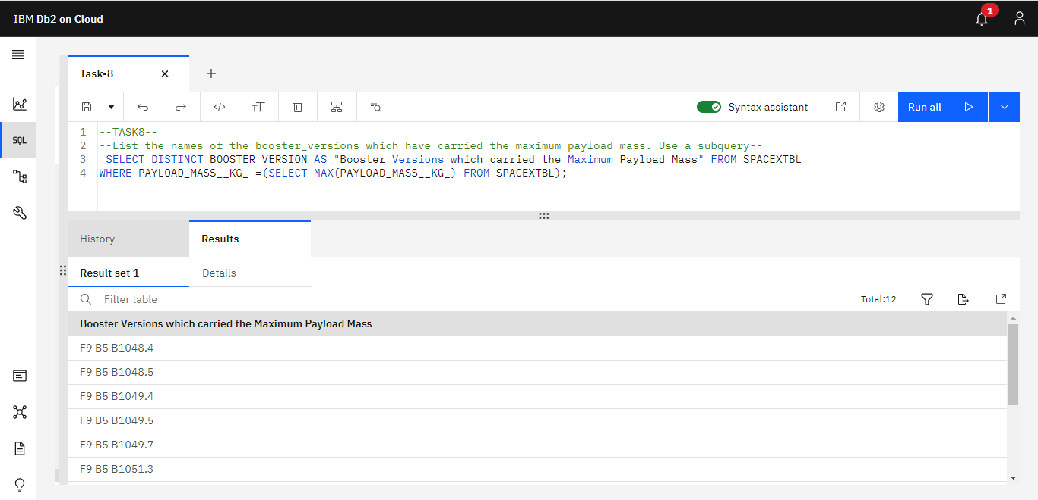

**Task 9**

##### *List the failed landing_outcomes in drone ship, their booster versions, and launch site names for in year 2015*

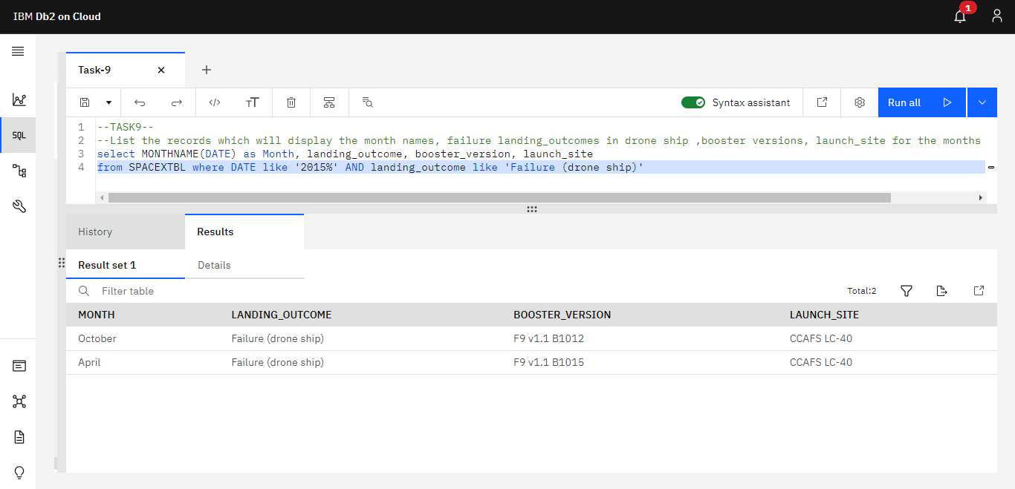

**Task 10**

##### *Rank the count of landing outcomes (such as Failure (drone ship) or Success (ground pad)) between the date 2010-06-04 and 2017-03-20, in descending order*

